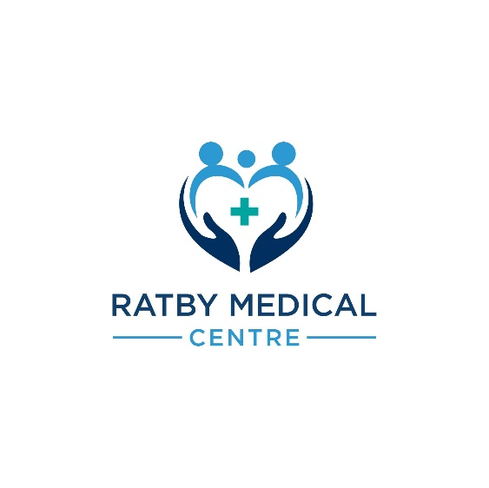

Ratby Medical Centre - Your Right to Choose: NHS Referrals to Alternative Care Settings Outside of Leicestershire

Dear Valued Patient,

At Ratby Medical Centre, we want to ensure you receive the best possible care and treatment that meets your needs and preferences. That's why we're pleased to inform you about your "Right to Choose" when it comes to your NHS referrals for healthcare services outside of Leicestershire. This leaflet provides you with essential information on how you can make an informed decisions about your care.

What is the Right to Choose?
The "Right to Choose" is a valuable NHS initiative that allows you, as a patient, to decide where you would like to receive treatment or care, particularly when you've been referred by your GP or another healthcare professional. This initiative empowers you to have a say in your healthcare journey.

Key Features of the Right to Choose:
- Choice of Provider:
You can choose a healthcare provider or hospital, both within and outside of Leicestershire, that best suits your needs. This includes NHS and private providers, if they offer the necessary services and meet NHS quality standards.

- Shorter Waiting Times:
If you're experiencing long waiting times for treatment in Leicestershire, exercising your right to choose may lead to quicker access to care in an alternative location.

- Personal Preferences:
You can consider factors such as location, reputation, and the facilities provided by the chosen healthcare provider, ensuring your comfort and convenience during treatment.

Important Note on Medication and Follow-up Care:
If you are prescribed medication by a non-Leicestershire-based healthcare provider, it is essential to be aware of the following:
- Prescribing Guidance:
The healthcare provider must adhere to Leicestershire prescribing guidance, formulary and monitoring when prescribing medication for you. This ensures that your treatment is safe and appropriate. If they do not adhere to this your medication may not be prescribed for you by the practice.

- In-Person Assessments:
For certain medications or treatments, you may be required to attend a clinic outside of Leicestershire frequently for observations (heart rate, blood pressure, heart tracings etc), blood tests or other monitoring requirements. Whilst we appreciate this is often ‘easier’ the does not have capacity, additional administrative time or any attached funding to be offering these appointments. Asking for this as a ‘one off’ is inequitable to all other patients who would also prefer this option – we appreciate your understanding in relation to this.

- Annual Review:
Some conditions or medications like ADHD medications require an annual review to assess the effectiveness and safety of your medication. Please note that Ratby Surgery will not continue these medications unless you are having the required reviews which would automatically happen if you chose a Leicestershire provider.

Regrettably, there have been cases in which individuals opted for an assessment under the Right to Choose, such as an ADHD assessment, but the alternative healthcare team did not adhere to Leicestershire's prescribing guidelines. As a consequence, their request for medication was denied, and instead, a local referral was initiated. This inadvertently caused delays in obtaining an appointment for a local assessment.

Things to Consider:
- Travel and Transportation: Think about how you will travel to the chosen location.

- Accommodation: If your treatment requires an overnight stay, consider where you will stay and whether the provider offers accommodation options.

- Frequency of appointments: Think about how often you will travel to the chosen location.

If you are happy to proceed and have chosen the location, you wish to be referred to please inform the practice team.

We are committed to supporting you in making the best decisions for your healthcare journey. Your well-being is our priority, and we are here to assist you every step of the way.

Kind regards,
Ratby Medical Centre Team

